1- Deploy a pod named nginx-pod using the nginx:alpine image with the labels set to tier=backend.

2- Deploy a test pod using the nginx:alpine image.



3- Create a service backend-service to expose the backend application within the cluster on port 80.



4- try to curl the backend-service from the test pod. What is the response?

nginx server index page

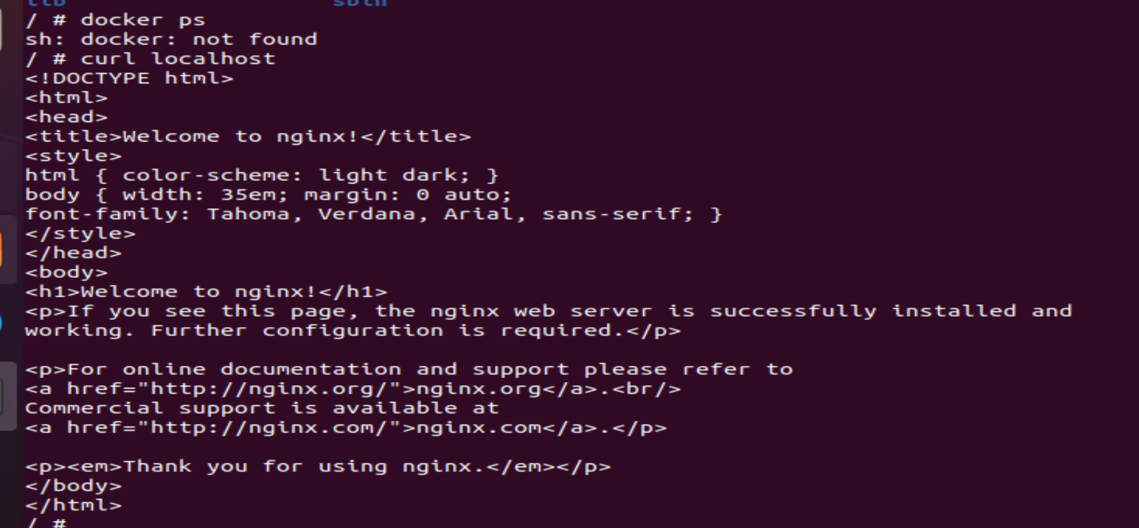

5- Create a deployment named web-app using the image nginx with 2 replicas



6- Expose the web-app as service web-app-service application on port 80 and nodeport 30082 on the nodes on the cluster

7- access the web app from the node

8- How many Nodes exist on the system?

1 node

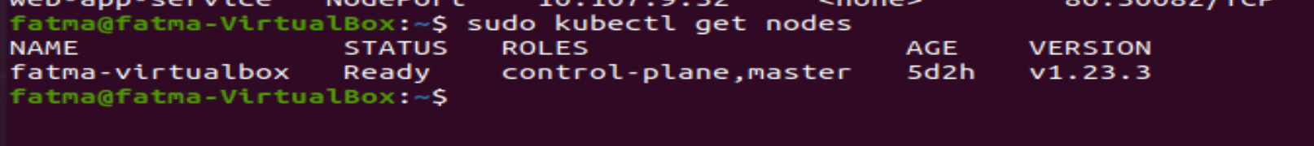

9- Do you see any taints on master ?

no





10- Apply a label color=blue to the master node

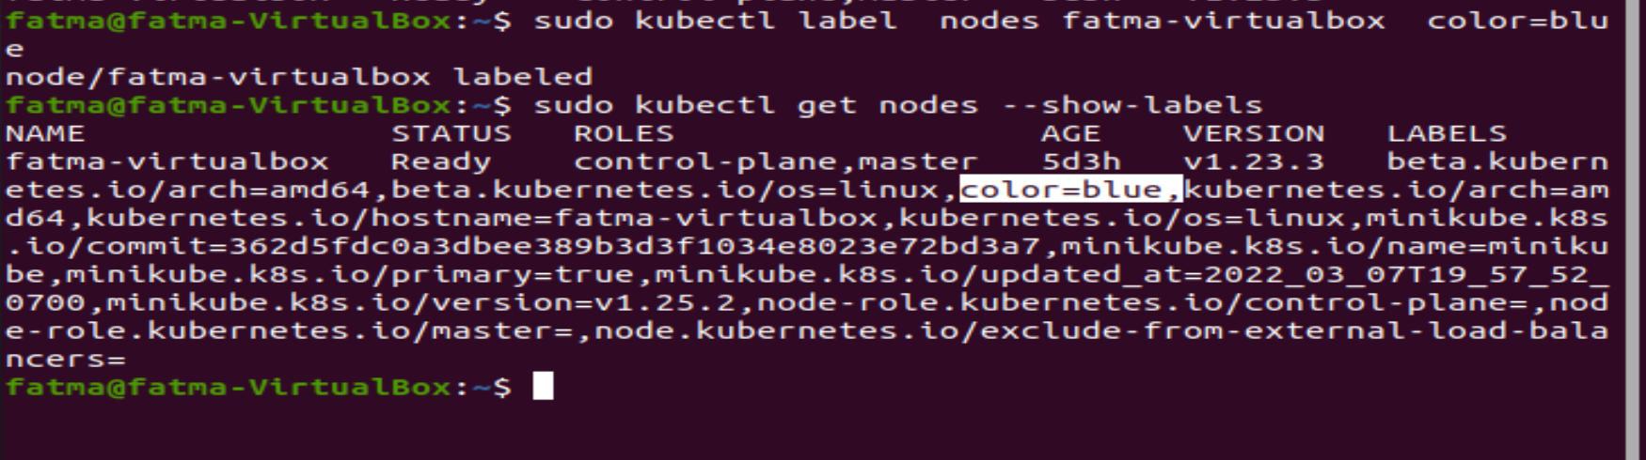

11- Create a new deployment named blue with the nginx image and 3 replicas

Set Node Affinity to the deployment to place the pods on master only

NodeAffinity: requiredDuringSchedulingIgnoredDuringExecution

Key: color

values: blue



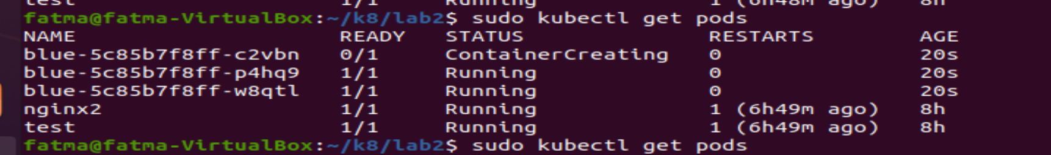

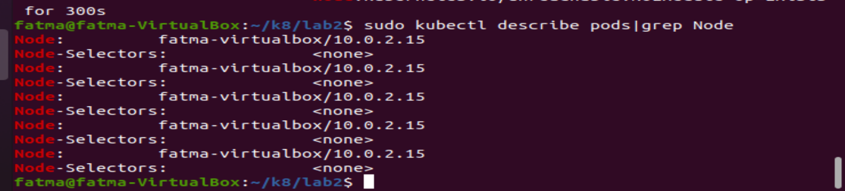

12- How many DaemonSets are created in the cluster in all namespaces?

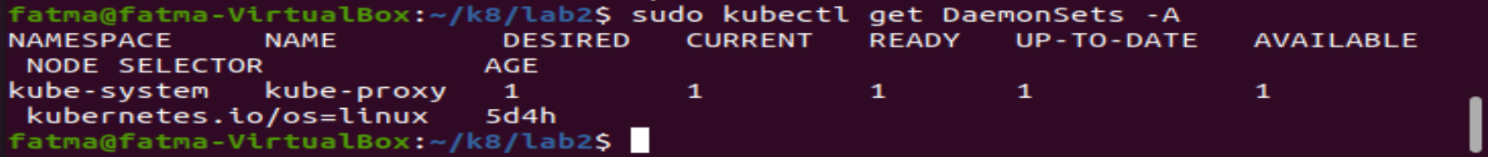

13- what DaemonSets exist on the kube-system namespace?

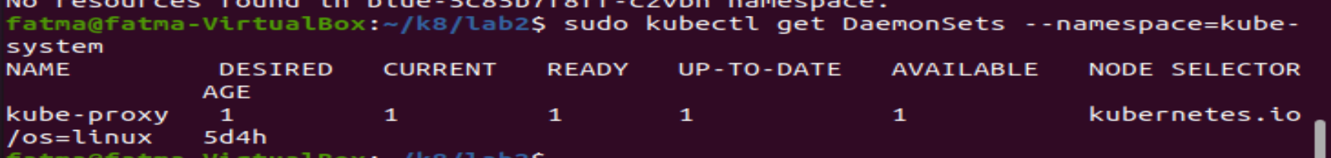

14- What is the image used by the POD deployed by the kube-proxy DaemonSet

kubectl describe daemonset kube-proxy -n kube-system | grep Image

or

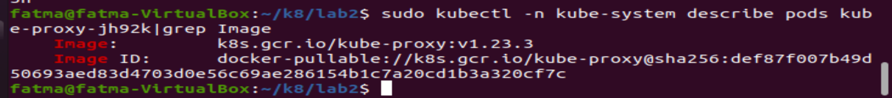

15- Deploy a DaemonSet for FluentD Logging. Use the given specifications.

Name: elasticsearch

Namespace: kube-system

Image: k8s.gcr.io/fluentd-elasticsearch:1.20

kubectl create -f Deamonset1.yaml

16- Create a taint on node01 with key of spray, value of mortein and effect of NoSchedule

kubectl taint nodes node01 spray=mortein:NoSchedule

17- Create a new pod named mosquito with the NGINX image

kubectl create -f mosquito.yaml

18- What is the state of the mosquito POD?

Running

19- Create another pod named bee with the NGINX image, which has a toleration set to the taint Mortein

Image name: nginx

Key: spray

Value: mortein

Effect: NoSchedule

Status: Running

kubectl create -f bee.yaml

20- Remove the taint on master/controlplane, which currently has the taint effect of NoSchedule

kubectl taint nodes fatma-virtualbox color=blue:NoSchedule-

21- What is the state of the pod mosquito now and Which node is the POD mosquito on?

kubectl describe pod mosquito

22- Create a job countdown-job.

The container should be named as container-countdown-job

Use image debian:latest, and restart policy should be Never.

Use command for i in ten nine eight seven six five four three two one ; do echo $i ; done

kubectl create -f job.yaml

kubectl logs job-55sct